Get a paper-review from a P.I by asking on Slack
- Two prerequisites before you can book a slot: 1) The draft must be near final 2) Your mentor needs to have given feedback first. If the paper is not in good shape, the PhDs will send it back to you guys to fix first. Hard to give feedback if the paper is incomplete (e.g missing sections or clearly a first draft)
- You must submit this at least one week before the conference deadline. Reasoning given below.

READ THIS IN-DEPTH, DON’T SKIM!!

- Do not begin writing until you read this document in full!
  - e.g If you’re starting your introduction, you need to read this in full first, then read our section-specific guide to the introduction.

There is a world of difference between a professional paper versus a university project report or a high school research paper.

Your writing needs to be spotless in order to have a chance to get accepted to a top-level conference, so please read and spend a lot of time on this.

We will only submit papers that have been reviewed by us first.
- We have never had a paper accepted without us reviewing it first, out of many attempts (always due to people cramming on the last day and thus not having time for us to review it - please don’t do this). Thus, we will not even submit the paper if it doesn’t get reviewed first for ethical reasons - reviewers in ML are already overburdened as is, and we don’t want to contribute to this problem. We will withdraw the paper if it is submitted without our review.
- Important: You must give us at least one week to give comments, and for you to revise the comments, and for us to do another review or two.
  - Why at least one week?
    - 1) Based on our comments, you will likely need to make a lot of changes and maybe run more experiments/analyses, which takes time.
    - 2) If tons of teams ask us at the same time all on the night of the deadline, we simply cannot handle all of them at once.
    - 3) Sean/Vasu/your mentor might be submitting their own papers on the day of the deadline as well

An example for why the writing needs to be near-perfect - this paper of ours was rejected despite having great results, thorough experiments and novelty.

All the comments were about the writing quality - see the strengths vs weaknesses. And this is even after hours of revision on the paper. The paper will need a lot of time to make sure it is bulletproof!
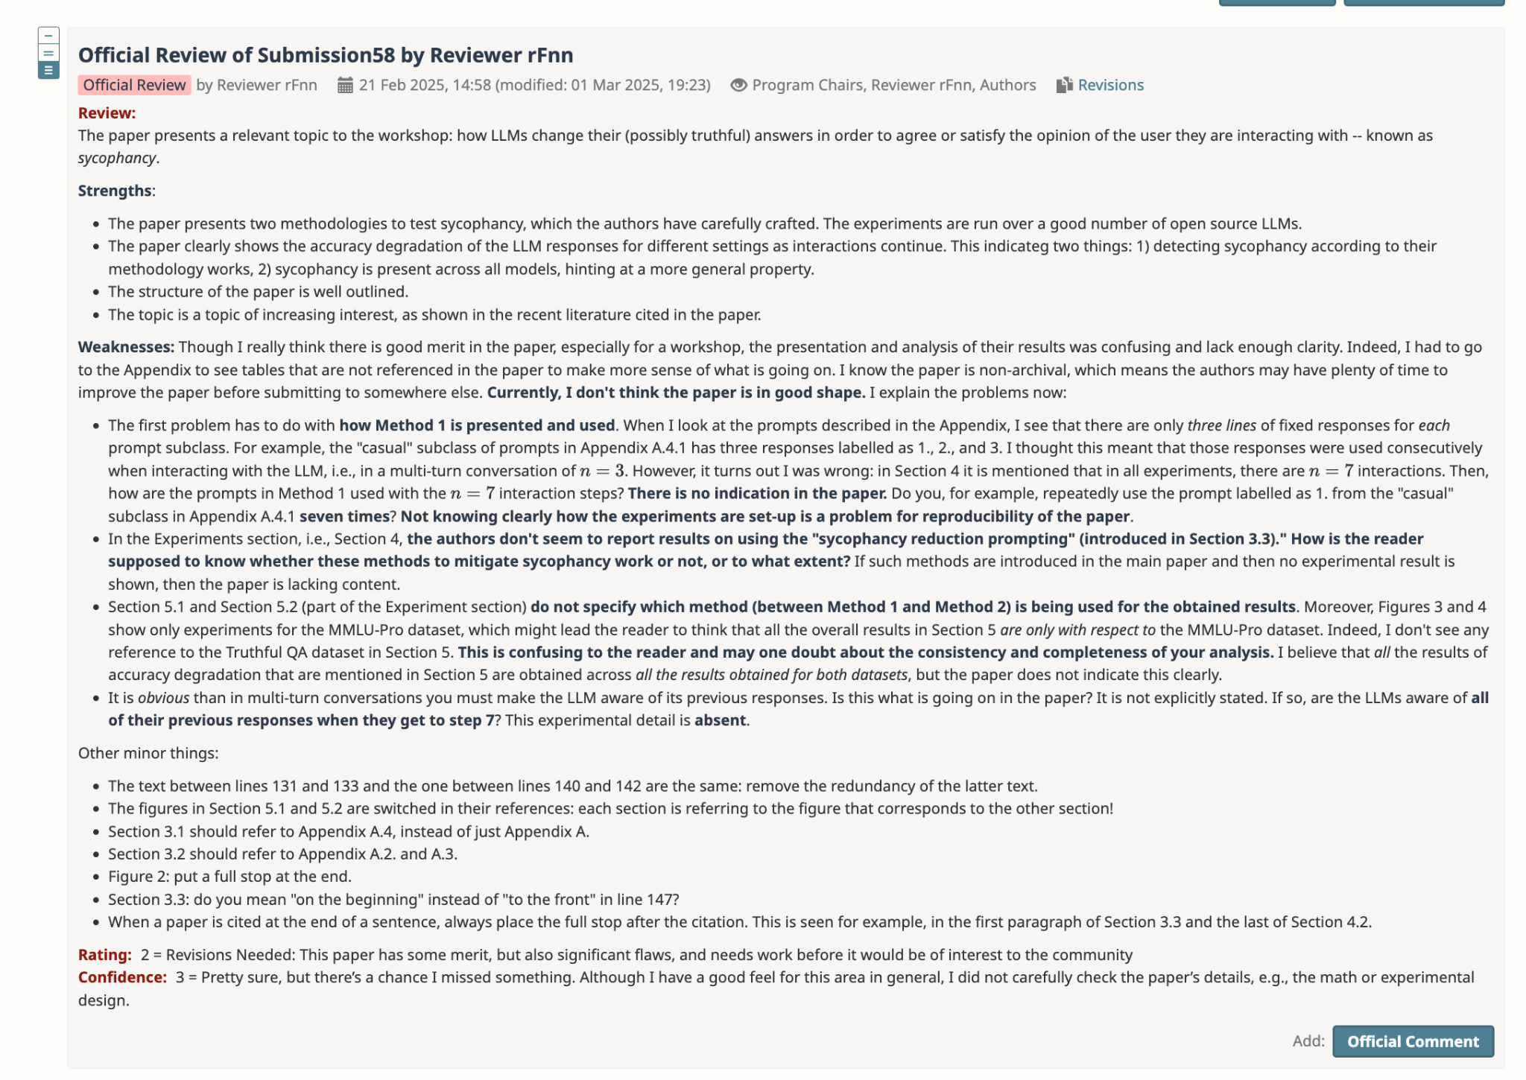

6 paper-writing guidelines, read this first.

Quick guidelines and tips:

- Use your research proposal as a guide for content.

- Pattern match from previous papers for writing-style in whatever conference you're submitting to, as well as closely related papers you cite, as a guide for writing style.

- Don’t just use ChatGPT for a first draft. Academic writing is difficult and can't be ChatGPT'd. Not even o3/o4 or GPT4.5. But it's okay to use ChatGPT during the editing process as long as you don't blindly copy paste its generations. I find it can be quite helpful sometimes.

- You can’t BS anything. Keep in mind, you might even unintentionally BS or exaggerate some stuff out of habit - be very mindful of this.
  - Avoid making claims without justifying them.
    - First step here is to be mindful - what sentences of yours are claims? Does it need proof? How does the reader know that it is true besides blind trust? You need citations to justify claims.
  - Avoid making logical leaps.
    - Again, be mindful - what is the logical sequence in your argument? Does each step immediately follow from the previous step?
  - Avoid exaggerating your contribution or novelty.
    - Reviewers can see through this and this will make reviewers treat your paper less seriously.
  - Make sure all statements you’re saying about the literature are actually true.
    - If you’re unsure, get it checked by your mentor. Do not assume. This is also grounds for rejection for the astute reviewer.

More on claims later in this guide.

- After reading this document in full, just get started and write an outline! Don't aim for perfection when getting started, and don't worry if you don't feel confident on what you're writing, that is expected if you're new to this. I do not want this document to scare you out of starting. You gotta start from somewhere.

Introduction to LaTeX and Overleaf: https://www.youtube.com/watch?v=dkojsBJ-S-g

  - For now, if we haven't specified a conference you should aim for, you can get started on google docs. Each conference specifies a template to use, so once we decide on a conference, we'll migrate to Overleaf, using the conference template. The conference will also specify page limits and other requirements.
  - Feel free to watch this later, after we migrate to Overleaf
  - When we give comments on your overleaf document, do not mark them resolved even after you address the comment, so they remain visible. Since it’s possible that it may not be addressed in the way that we’d like. Instead, reply “done” and we may take a second look.

How to write papers. End-to-end guide. Must read:
  - https://www.alignmentforum.org/posts/eJGptPbbFPZGLpjsp/highly-opinionated-advice-on-how-to-write-ml-papers

Why you should begin writing now and general advice on paper-writing: https://www.cs.jhu.edu/~jason/advice/write-the-paper-first.html
  - (Optional) More great high-level advice on paper-writing, roughly a 20 minute clip https://www.youtube.com/live/W1zPtTt43LI?si=dML3otad9FEjJFb1&t=664

Planning paper-writing: https://deviparikh.medium.com/planning-paper-writing-553f497e8839
  - Start with an outline, don't go straight to writing. More details in the post.

Formal, academic-style writing guide: https://shomir.net/scholarly_writing.html
  - There's some common mistakes I've seen, such as: "Invoke Trendiness Sparingly", "Avoid Aspirational Predictions", "Avoid Vague Judgmental Language". This will make sense after reading that post.
  - When to use parenthetical and textual citations, and how to cite multiple papers in one sentence: link
  - How to write captions for figures: link

  - In general, you can kind of think of your paper as a mathematical proof, and reviewers as super strict claim verifiers. Every claim you make must be backed by a citation, take a look at some other papers for reference: https://sslneurips23.github.io/paper_pdfs/paper_62.pdf. Even something as broad as something like "Machine learning (ML) is a rapidly growing field that has significantly contributed to molecular design for drug discovery" must be supported by citation(s).
    - And make sure the citations you choose actually support your claim, not just cherry-picked papers that are sort of relevant. This can be grounds for rejection if you're not careful.
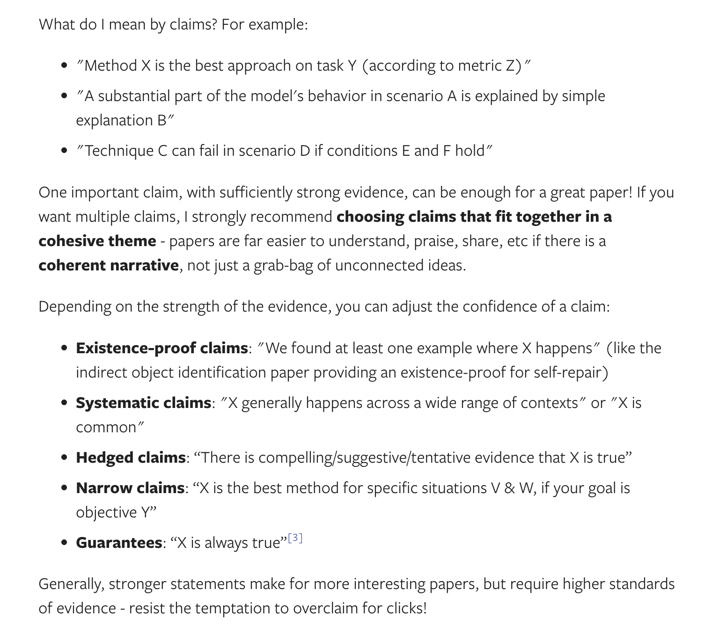

Section-specific guides:
In general, pattern match from other papers you read. But here’s some more structural guidelines:

TLDR:
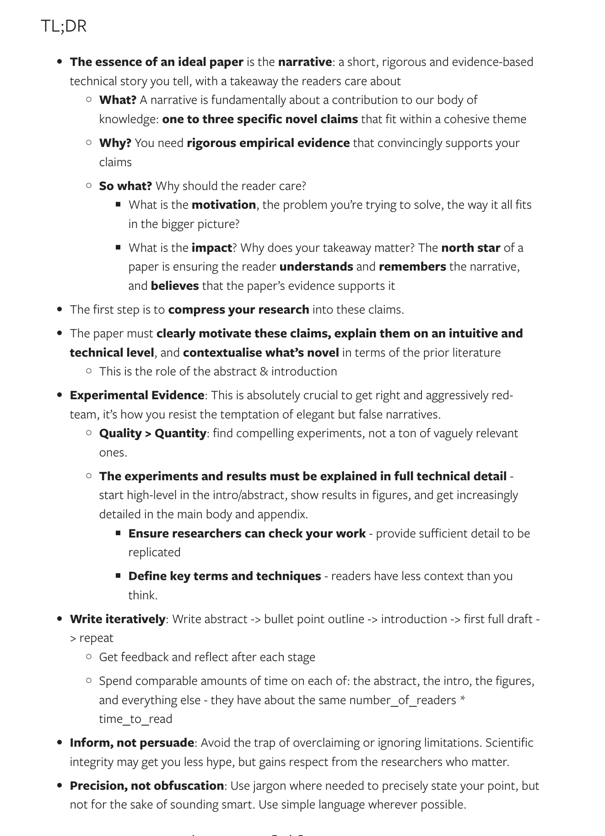

Abstract:
- In general, a good abstract should go:
  - Brief topic + motivation
  - Brief background/context
  - Brief method description
  - Brief results
  - Brief takeaways
- Checklist: https://github.com/yzhao062/cs-paper-checklist?tab=readme-ov-file#1--title-and-abstract
- Read the relevant section here, cmd-F “abstract”: https://www.alignmentforum.org/posts/eJGptPbbFPZGLpjsp/highly-opinionated-advice-on-how-to-write-ml-papers
- More details: https://users.ece.cmu.edu/~koopman/essays/abstract.html
- Example of a well-written abstract: https://arxiv.org/abs/2203.11171
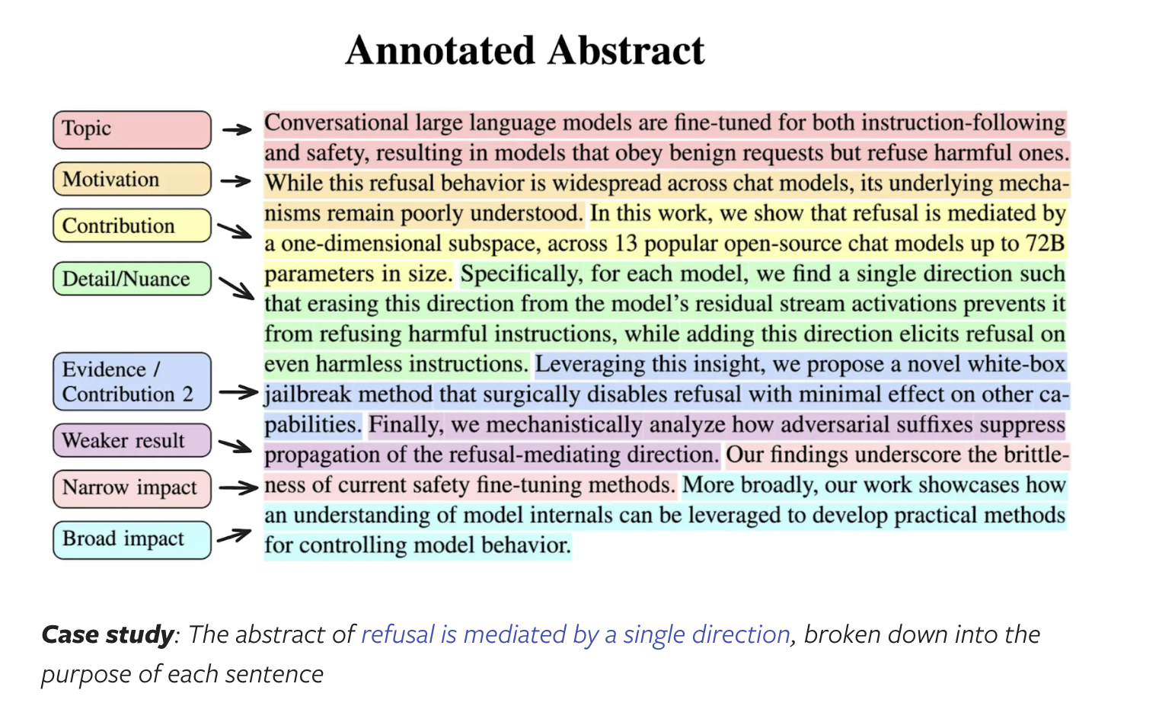

Introduction:

It must follow the below structure:

from Celine:
- motivation: why should the reader care? why should a person in general care what we’re doing here?
- context / introduce the gap: what are existing approaches? why aren’t they good enough?
- motivate the insights of our methods; make Research Question(s) clear from your writing.
- summarize our methods
- summary of contributions to the field & results

- The end of your introduction should explicitly list your paper's contributions to the research field.
- Look at the introduction sections of the papers you're citing. There should be some overlap here.
- Example of a well-written introduction: https://arxiv.org/abs/2203.11171.
  - This goes a lot more in depth on the method in the introduction than usually recommended.

- Read the relevant section here, cmd-F “introduction”: https://www.alignmentforum.org/posts/eJGptPbbFPZGLpjsp/highly-opinionated-advice-on-how-to-write-ml-papers
- Another resource: https://x.com/jbhuang0604/status/1638029732347367429
- Checklist: https://github.com/yzhao062/cs-paper-checklist?tab=readme-ov-file#2--introduction

Background
This section is optional - depending on how much background is necessary to understand your project. You can reach out to your mentor to see if you should include a section for this.

As a rough heuristic, if there’s a lot of non-ML domain knowledge necessary to understand what’s going on, it could be useful to include a section like this.

Using a coding analogy, this is like the “import” section of your paper.
- Introduce all notation used
- Sufficiently describe all relevant background needed in order to explain the methods & results

- Read the relevant section here, cmd-F “Background”: https://www.alignmentforum.org/posts/eJGptPbbFPZGLpjsp/highly-opinionated-advice-on-how-to-write-ml-papers

Method

Describe your method very clearly. This is not the place to make unsubstantiated claims about intuition or metaphors. Should be procedural. Do not use any notation not introduced in the background section. This is the main content, and readers will likely spend most of their time thinking about what you say here.

- Read the relevant section here, cmd-F “Method”: https://www.alignmentforum.org/posts/eJGptPbbFPZGLpjsp/highly-opinionated-advice-on-how-to-write-ml-papers
- Checklist: https://github.com/yzhao062/cs-paper-checklist?tab=readme-ov-file#4--method

Example good method sections in some past papers of ours:
- Example in a method paper: https://www.overleaf.com/read/rttcdfvjkxzd#14b47a
- Example in a benchmark paper, see section 3: https://www.overleaf.com/read/vckqjfjshjkp#bee2cc

Method diagram or first page diagram:
- A useful tool to create diagrams: https://draw.io/
- Another useful tool to create graphics: https://vecta.io/
- A great diagram can greatly enhance a paper. Some examples:
  - https://arxiv.org/abs/2305.14739
  - https://arxiv.org/pdf/2201.11903
  - https://arxiv.org/pdf/2311.08774

Some examples of ours (but don’t overfit to this, please create whatever makes most sense in your context):
From vecta.io:
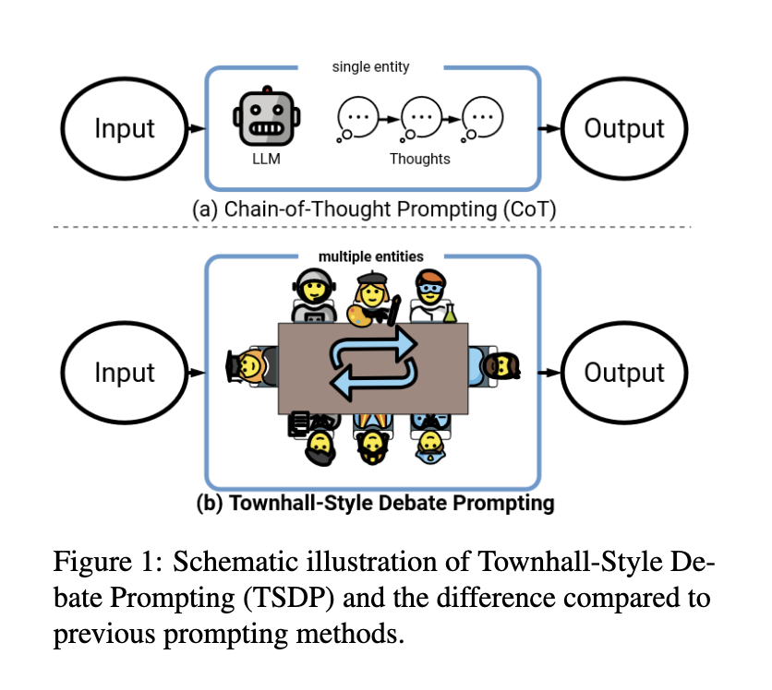
From draw.io
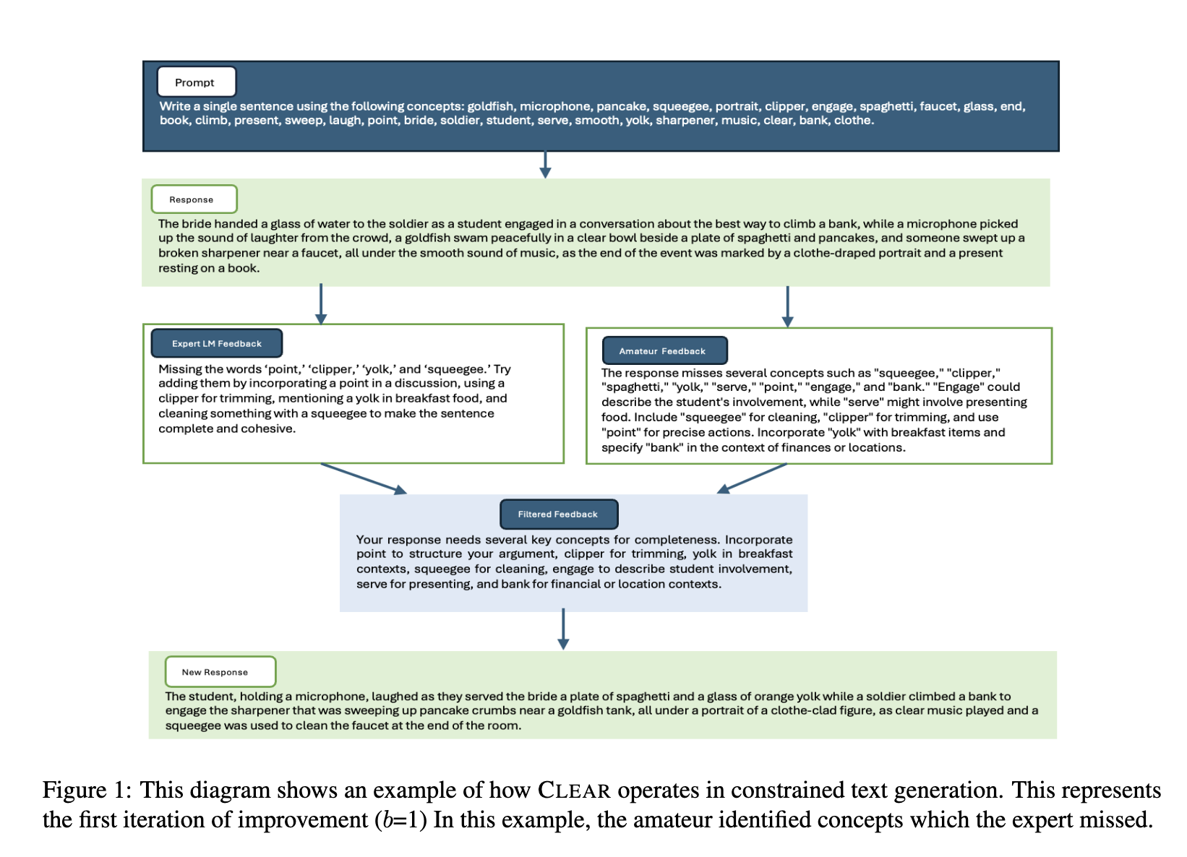

Experiments

Details of how you implement your method. model choice, parameter choice, baselines, datasets, etc.

- Detail the 1. datasets (e.g data source and a description of the dataset contents) and the 2 and/or 3. models/methods.
  - If you’re introducing a benchmark, you should elaborate a lot more on the dataset. See section 3 and 4 here for reference: https://aclanthology.org/N19-1421.pdf
- Examples:
  - See section 3: https://arxiv.org/pdf/2402.03620.
  - Section 4: https://arxiv.org/pdf/2401.10695.

Checklist: https://github.com/yzhao062/cs-paper-checklist?tab=readme-ov-file#5--experiments

- Describe the "what" in detail, but not the basics of the "how". Assume reviewers have a strong ML and programming background.
- DO include important details like hyperparameters if you trained a model, as that's necessary to reproduce your work.
- But DON'T include "how" details like you wrote python scripts to process a CSV file or that you used a pandas merge.

- If there’s a ton of hyperparameters, you can put that in an appendix instead and link that in this section.

Additional resource: https://grigorisg9gr.github.io/machine%20learning/research%20paper/how-to-write-a-research-paper-in-machine-learning/

Results and analysis
- Clearly answer the RQs. Don’t go talking about unrelated things. Do ablations as necessary.
- Important: Figure and table captions should be self-contained. This means, be very descriptive in the caption and highlight the main takeaway from the table/figure. Do not just label it “GPT results” or something like that.
- Display your experimental results in tables.
- Make sure all figures have all necessary details (including labels for axes!), aren’t too big or too small, and aren’t blurry.
- In the writing part of the section, don’t rehash the same thing that’s in the tables. Highlight important observations and interpretations (but don’t overstate your results). Avoid number dumping.

- Read the relevant section here, cmd-F “Results”: https://www.alignmentforum.org/posts/eJGptPbbFPZGLpjsp/highly-opinionated-advice-on-how-to-write-ml-papers
- Checklist: https://github.com/yzhao062/cs-paper-checklist?tab=readme-ov-file#7-%EF%B8%8F-figures-and-tables

Related Works

Find at least 10-20 papers that are related to your paper
- Go from general to specific to more specific

Reviewers need to be convinced that YOU are an expert in your subfield and that you’re aware exactly how your paper is different from other papers.

Recommended: 3 axes of research related to your method. Related works relating to each. Say (briefly) why yours is different.

In most cases, I prefer for this section to be the second to last section in the paper rather than having it as the second section in the paper after the intro. It flows better this way - the intro should have the reader begging to see what the method is, which should have the reader begging to read the experiments, which should leave the reader begging to see the results. Unless, the related works is highly relevant to motivate the method.

- Read the relevant section here, cmd-F “Related work”: https://www.alignmentforum.org/posts/eJGptPbbFPZGLpjsp/highly-opinionated-advice-on-how-to-write-ml-papers
- https://github.com/jbhuang0604/awesome-tips/blob/main/related-work.md
- Look at the related works sections of the papers you're citing. There should be some overlap here.

Conclusion
- Doesn’t matter that much so don’t spend too much time optimizing this - just summarize the takeaways. Generally, start specific then go more broad.

- My preference is to not talk about future work or limitations here - put that in a discussion section if you'd like. IMO, those detract from your contributions and leave the reviewer at the end feeling like your paper is missing stuff.

Limitations
- For *ACL conferences (e.g ACL, EMNLP, NAACL, COLING), you need a separate limitations section that goes below the conclusion and does not count towards the page limit.
  - Example good limitations section, see section 6: https://www.overleaf.com/read/rxrqsvyvxjbq#921dff

Appendix
Things you may include:
- Specific prompts you used (if LLM-based)
- Other implementation details
- Secondary results and visualizations of more detailed analyses
- Example data points (if benchmark/dataset paper)
- Example results of your method

Chat with your mentor on what should be included here.

- Example good appendix 1: https://www.overleaf.com/read/rxrqsvyvxjbq#921dff
- Example good appendix 2: https://arxiv.org/pdf/2410.07839

Creating an Open Review account

This doesn’t matter very much since reviewers won’t see this information (since submission is anonymous). But you need to do it to create an account. It takes two weeks to get approved, but you don’t need to be approved at the time of submission for most conferences. Though some do, so might as well do this now as you read this sentence.

https://openreview.net/signup

If you’re a university student, use your university. If you’re a high school student, you can put Algoverse - see below (change 2023 to 2025). If you continue with research at a university in the future, you can change this later.


Sometimes, putting Algoverse as the affiliation doesn’t work. In this case, reach out to me and I can give you a temporary algoverse email.

You can put me and your mentor as co-authors.

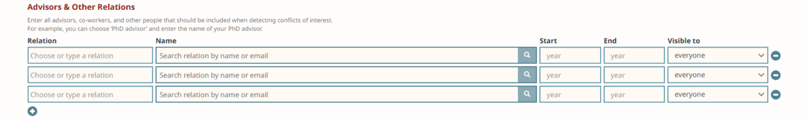

Final Review Checklist:
- Check to make sure you follow all style requirements so you don’t get desk rejected.
  - Need line numbers (most of the time).
  - Make sure tables, graphics, and captions are formatted correctly.
- Submissions should be anonymous (almost always).
- Submission needs a title
- Make sure any linked githubs or anything are anonymous as well, use this tool: https://anonymous.4open.science/
  - We’ve gotten desk rejected once before for forgetting to anonymize a huggingface link. Also, do not include an acknowledgements section.

Checklist: https://github.com/yzhao062/cs-paper-checklist?tab=readme-ov-file#11--sanity-checks-before-submission

- Experimental if you guys have time, Celine's advisor has this LLM paper reading linter that may or may not be useful: https://github.com/srush/prof8. If you try it, let me know if it helps!
- Trimming your paper length:https://deviparikh.medium.com/shortening-papers-to-fit-page-limits-97601318681d
- General checklist - worth reading now as a guideline and again later as a final review: https://icml.cc/Conferences/2022/BestPractices. This checklist is from ICML, but applies in general.

In general, feel free to ping us anytime if you have questions or would like a pair of eyes on what you have so far!

Rebuttals
- https://deviparikh.medium.com/how-we-write-rebuttals-dc84742fece1
- An example: https://openreview.net/forum?id=SzV37yefM4
- Guidelines (from NeurIPS, but broadly applicable): link

